**Market Research for DicountMate Project**

**Company: DataBytes**

Contents

1. Frugl 4

1.1. What is Frugl? 4

1.1. Key Features of Frugl: 4

1.2. Advantages of Frugl: 5

1.3. How Frugl Stands Out Against Competitors: 5

1.4. Potential Weaknesses: 6

1.5. Target Audience: 7

1.6. User Interface (UI) and User Experience (UX): 7

1.7. Data Collection 7

2. WiseList 9

2.1. What is WiseList? 9

2.2. Benefits of WiseList: 9

2.3. How WiseList Compares to Competitors: 10

2.4. Competitor Products: 10

2.5. Comparison Chart: 10

2.6. Unique Features: 11

2.7. Potential Weaknesses: 11

2.8. Target Audience: 12

2.9. Pricing Model: 12

2.10. Integration Potential: 13

Future Trends: 13

2.11. User Interface (UI) and User Experience (UX) 14

3. PayPal Honey 16

3.1. What is PayPal Honey? 16

3.2. Key Features of PayPal Honey: 16

3.3. Advantages of PayPal Honey: 16

3.4. How PayPal Honey Stands Out Against Competitors: 17

3.5. Competitor Extensions: 17

3.6. Unique Strengths: 17

3.7. Potential Weaknesses: 18

3.8. Target Audience: 18

3.9. Integration Potential: 18

3.10. Future Trends: 18

3.11. User Interface (UI) and User Experience (UX): 19

3.12. Data Collection 20

# Frugl

## What is Frugl?

The Frugl app aims to revolutionizes the shopping experience for Australian by empowering users to compare products and prices between Woolworths and Coles supermarkets. Through this comparison, users can customize their shopping lists for each store, ensuring a tailored experience to their preferences. Frugl gathers product and pricing data from multiple retailers before further organizing and enriching it via automated processing and Machine Learning. The data is made available to shoppers via the Frugl Grocery mobile comparison and wellness app, with app usage generating additional retail intelligence in the form of behavioral and shopper segment data.

## Key Features of Frugl:

* **Price comparison:** Frugl utilizes cutting-edge technology to compare prices across various retailers within users' local areas.
* **Wellness Tools Integration:** In addition to price comparison, the new Frugl app incorporates wellness tools. These tools enable shoppers to evaluate products based on nutritional value, ingredient listings, allergen inclusions, health ratings, and sustainability factors, facilitating optimized shopping baskets.
* **Provide recipe page for different healthy foods:** Frugl provides a dedicated recipe page for a diverse range of delicious meal options. Users can explore a wide range of recipes tailored to various dietary preferences, including vegetarian, vegan, gluten-free, and more.
* **Grocery Pricing & Promotion Analytics Platform:** Frugl introduces its Grocery Pricing & Promotion Analytics platform, leveraging data collected since May 2019.
* **Data Analytic platform for retailors:** Frugl confirms its venture into commercializing data analytics products. By engaging in discussions with major Australian retailers and grocer suppliers, Frugl aims to align with their data analytics objectives and offer tailored analytics solutions to meet their needs.

## Advantages of Frugl:

* Save money on every shopping: Discover savings on thousands of products each week from grocery retailers across Australia, helping you stretch your budget further.
* Customize and refine search results based on dietary needs and allergens: Tailor your shopping experience by setting dietary preferences or highlighting allergens, ensuring that products align with your specific requirements.
* Effortlessly find what you need: With the ability to search through over 50,000 available products or simply scan the barcode, locating items has never been easier.
* Scan product barcodes on the go: Streamline your shopping experience by scanning product barcodes directly from your mobile device, instantly accessing pricing and comparison information.
* Earn Rewards with every purchase: Accumulate Honey Gold points with each purchase, unlocking additional savings opportunities for future shopping trips.
* Save time with built-in comparison tools: Simplify the process of comparing prices across multiple sites with our integrated comparison tool, minimizing the time and effort required for smart shopping.
* Seamlessly integrate wellness tools: In addition to price comparison, the Frugl app integrates wellness tools to help users make informed choices about their purchases. Evaluate products based on nutritional value, ingredient listings, allergen information, health ratings, and sustainability factors, ensuring your shopping basket aligns with your health and wellness goals.
* Explore a variety of healthy recipes: Dive into our dedicated recipe page featuring a diverse selection of nutritious meal options. Whether you're vegetarian, vegan, gluten-free, or have other dietary preferences, discover delicious recipes tailored to suit your lifestyle.

## How Frugl Stands Out Against Competitors:

Frugl sets itself apart from competitors through a range of distinctive features:

* + **Enhanced List Management:** Introducing new List features such as Favorites and Custom lists, allowing users to curate their shopping experience with ease. Additionally, Frugl enables the import of saved lists from external sources, such as recipe ingredient lists, streamlining the shopping process further.
  + **Collaborative and Household Lists:** Facilitating seamless collaboration among multiple users within households, Frugl's Household lists feature ensures that everyone can contribute to and benefit from shared shopping lists, fostering greater convenience and coordination.
  + **Advanced Filtering Options:** Frugl empowers users to refine their search results based on dietary preferences and allergies, providing a personalized shopping experience tailored to individual needs and ensuring peace of mind while browsing for products.
  + **Barcode Scanning Capabilities:** With Frugl's intuitive barcode scan functionality, users can effortlessly obtain detailed product information and pricing, enabling quick and informed purchasing decisions while on the go.
  + **Comprehensive Analytics for Retailers:** Frugl goes beyond consumer-facing features by offering valuable analytics tools tailored for large supermarkets and retailers. These analytics provide insights into shopper behavior, preferences, and trends, empowering retailers to optimize their offerings and enhance the shopping experience for their customers.

## Potential Weaknesses:

* **Limited Retail Coverage:** Frugl's current limitation lies in its exclusive coverage of Coles and Woolworths supermarkets
* **Lack of Receipt Imaging Functionality:** One notable weakness of Frugl is its absence of a feature allowing users to capture and store images of their receipts. This functionality could be invaluable for users who wish to track their spending, monitor purchases, or participate in cashback programs.
* **Limited Platform Accessibility:** Frugl's availability solely as a mobile app represents a potential weakness for users who prefer to access such services through web browsers or desktop platforms.

## Target Audience:

* + **Bargain Hunters:** Catering to savvy shoppers who are always on the lookout for the best deals and take pride in maximizing their savings on every online purchase.
  + **Insight for Supermarkets and Retailers:** Providing valuable insights into shopper behavior for large supermarkets and retailers, empowering them to understand their customers better and tailor their offerings to meet evolving needs and preferences.

## User Interface (UI) and User Experience (UX):

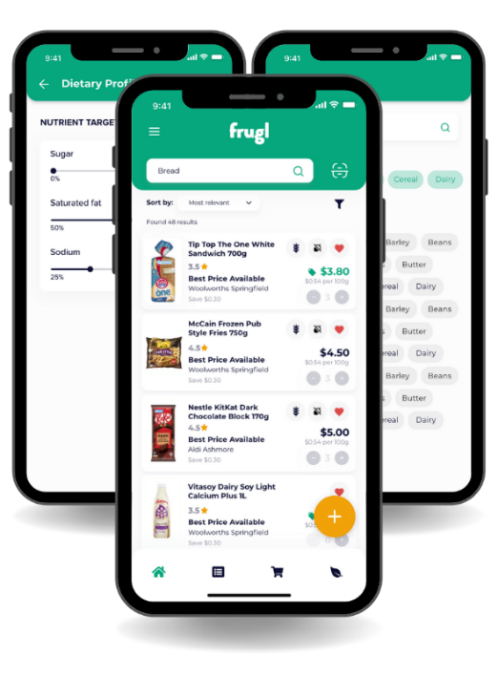

## Data Collection

According to data privacy of Frugl, here are the data that Honey collected during usage.

* **Personal Data:** Email address
* **Usage Data:** Usage Data may include information such as Your Device’s Internet Protocol address (e.g. IP address), browser type, browser version, the pages of our Service that You visit, the time and date of Your visit, the time spent on those pages, unique device identifiers and other diagnostic data.
* **Information from Third-Party Social Media Services:** The Company allows You to create an account and log in to use the Service through the following Third-party Social Media Services: Google, Facebook, Twitter. If You decide to register through or otherwise grant us access to a Third-Party Social Media Service, we may collect Personal data that is already associated with Your Third-Party Social Media Service’s account, such as your name, your email address, Your activities or Your contact list associated with that account.
* **Information Collected while Using the Application:** While using Our Application, in order to provide features of Our Application, we may collect, with Your prior permission: Information regarding your location, Pictures and other information from your Device’s camera and photo library.

# WiseList

## What is WiseList?

WiseList is an all-in-one app designed to simplify daily life through AI-powered organization tools. WiseList aims to simplify daily life through an AI-powered app that helps users manage tasks like shopping, meal planning, finances, and compare prices. This market research plan outlines the strategy to gather user insights of the WiseList app and to gather information on how it effectively meets the needs of its target audience. It offers functionalities like:

* Smart shopping: Compare prices and create grocery lists.
* Price comparison: Find the best deals on groceries with comprehensive price comparison tools.
* Collaborative lists: Share grocery lists with family members in real-time.
* Loyalty card integration: Add and scan loyalty cards for seamless checkout.
* AI-powered meal planning: Generate meal plans synced with shopping lists.
* Simplified finances: Track bills, manage subscriptions, and gain insights into spending.
* Customizable lists: Create lists for various purposes.
* AI assistance: Get answers to questions, summarize documents, and receive help building custom lists.
* Community sharing: Share templates and browse lists created by the community.

## Benefits of WiseList:

* Saves time and money on groceries through price comparison and efficient shopping tools.
* Reduces food waste with AI-powered meal planning and recipe suggestions based on existing groceries.
* Simplifies financial management through bill tracking, subscription organization, and spending insights.
* Enhances organization across various aspects of life with customizable lists and note-taking functionalities.
* Offers AI assistance through Ask WiseList for various tasks and list creation.
* Fosters community by allowing users to share list templates and discover new organization solutions.
* Reducing food waste through AI-powered meal planning and recipe suggestions.
* Gaining insights into spending habits and managing finances more effectively.

## How WiseList Compares to Competitors:

There are several products like WiseList that inform consumers about grocery discounts across supermarkets. Here's a breakdown comparing WiseList to some competitors:

## Competitor Products:

* Frugl Grocery (Australia): Focuses on price comparison for groceries in Australia, offering features like flyers, specials, and loyalty card integration.
* Half Price Grocery Deals (US/Canada): Provides digital coupons, grocery flyers, and in-store promotions across major North American supermarket chains.
* ShopAdvisor (US): Aggregates grocery deals and coupons from various sources, allowing users to create shopping lists and track past purchases.
* Snap (US): A grocery receipt scanning app that helps users track spending, earn cash back for purchases, and discover personalized deals.

## Comparison Chart:

|  |  |  |  |  |  |
| --- | --- | --- | --- | --- | --- |
| Feature | WiseList | Frugl Grocery | Half Price Grocery Deals | ShopAdvisor | Snap |
| Region Focus | Australia | Australia | US/Canada | US | US |
| Solutions Offered | Price comparison, smart shopping lists, AI-powered meal planning, finances, customizable lists | Price comparison, shopping lists, flyers, specials | Digital coupons, flyers, in-store promotions | Grocery deals, coupons, shopping lists, past purchases tracking | Receipt scanning, cash back, personalized deals |
| Benefits | Saves time and money on groceries, simplifies meal planning, helps manage finances | Helps find best deals, simplifies grocery shopping | Helps find coupons and deals, in-store promotion awareness | Helps find deals and coupons, simplifies shopping list creation | Saves money through cash back, personalized deals, budgeting insights |
| Competitive Edge | AI-powered features (meal planning, list suggestions), collaborative lists, Ask WiseList (AI assistant) | Strong focus on Australian market, loyalty card integration | Extensive coupon database, focus on North American market | Categorized deals, past purchase tracking | Receipt scanning for budgeting and personalized deals |

## Unique Features:

WiseList offers several unique features that set it apart from competitors:

* AI-Powered Meal Planning: WiseList provides recipe inspiration, generates meal plans synced with shopping lists, and even turns receipts into meal ideas to reduce food waste. This feature offers users personalized meal suggestions tailored to their dietary preferences, helping them plan meals efficiently.
* Health Score and Dietary Insights: WiseList offers users a personalized health score for their entire grocery list or individual items, along with detailed nutritional information, including calories, macronutrients, vitamins, and allergens. This feature helps users make informed choices about their food purchases and supports their health and wellness goals.
* Collaborative Shopping Lists: WiseList allows users to share their grocery lists with family members in real-time, facilitating organized shopping trips and ensuring that everyone is on the same page. This collaborative feature promotes efficiency and convenience for users managing household shopping responsibilities.

## Potential Weaknesses:

* Focus on a broader range of functionalities (organization, finances) might dilute the core grocery shopping experience compared to competitors solely focused on groceries.
* AI-powered features like Ask WiseList might be in early stages and require further development for optimal user experience.
* Limited availability of grocery stores for price comparison.
* Lack of advanced AI capabilities for personalized suggestions and assistance.
* Inadequate community engagement features for sharing and discovering new solutions.

## Target Audience:

The target audience for this research includes individuals who struggle with daily organization and are interested in solutions for managing tasks like shopping, meal planning, and finances. While WiseList caters to a broad audience seeking daily organization:

* Budget-Conscious Shoppers:
  + WiseList: Leverage price comparison, loyalty card integration, and budget-tracking features within its finance section.
  + Competitors (Frugl Grocery): Focus heavily on price comparison and flyers with special offers.
* Families:
  + WiseList: Emphasize collaborative shopping lists, meal planning with kid-friendly options, and customizable lists for household chores.
  + No direct competitor in Australia, but some recipe-focused apps with family meal planning might target this group.
* Health-Conscious Consumers:
  + WiseList: Highlight AI-powered insights on nutritional information, recipe suggestions based on dietary needs (gluten-free, vegan, etc.), and potential integration with fitness apps.
  + Competitors might offer basic dietary filters for grocery shopping, but WiseList's AI features could provide a strong differentiator.

## Pricing Model:

* Research WiseList's current pricing model (free with in-app purchases or subscription of $3.99/month).
* Consider offering a free tier with basic functionalities and premium tiers with advanced features (e.g., unlimited collaborative lists, personalized meal plans).

## Integration Potential:

Strategic integrations with other services that enhances WiseList's value proposition:

* Recipe Apps: Integrate with recipe apps to allow seamless import of ingredients into WiseList shopping lists and meal planning.
* Loyalty Program Management: Partner with loyalty programs to streamline card management within WiseList and offer personalized deals based on user purchase history.
* Delivery Platforms: Integrate with grocery delivery platforms for convenient ordering directly from WiseList.

## Future Trends:

Upcoming trends in grocery shopping and adapt projects to stay ahead of the curve:

* Voice-Activated Shopping: Consider integrating voice-activated shopping list creation or recipe search functionalities.
* Personalized Recipe Recommendations: Leverage AI to develop personalized recipe recommendations based on user preferences, dietary needs, and existing grocery lists.
* Real-Time Inventory Management: Explore partnerships with supermarkets for real-time inventory updates within WiseList, allowing users to verify product availability before shopping.
* Enhanced AI capabilities for predictive shopping suggestions and automated replenishment.
* Integration with smart home devices and IoT (Internet of Things) technology for seamless shopping experiences.
* Expansion into emerging markets or demographic segments with specific grocery shopping needs and preferences.

## User Interface (UI) and User Experience (UX)

# PayPal Honey

## What is PayPal Honey?

PayPal Honey is a browser extension that enhance online shopping experiences. It’s designed to integrate seamlessly with users' browsers to help find the best deals and apply coupon codes at checkout. This market research document will explore how PayPal Honey operates to streamline online purchases and how it fulfils the expectations of its users.

## Key Features of PayPal Honey:

* **Automatic Coupon Application:** Detects and applies the best coupon codes at checkout to save users time and money.
* **Deal Discovery:** Finds the best possible deals across thousands of online retailers and informs users of price drops.
* **Price History:** Tracks price changes over time to help users make informed purchase decisions.
* **Rewards Program:** Offers Honey Gold points that can be redeemed for gift cards or other perks as part of PayPal's rewards.
* **Wish List:** Allows users to save items from any site and notifies them of price drops or available coupons.
* **Price Comparison:** Automatically compares prices of a product across different retailers within the same window.
* **Travel Rewards:** Provides additional benefits such as earning Honey Gold when booking travel-related services through partner sites.
* **Exclusive Offers:** Grants access to special discounts and promotions exclusively for Honey members.

## Advantages of PayPal Honey:

* **Saves Money:** Automatically finds and applies discounts, reducing the cost of online purchases.
* **Efficient Shopping:** Streamlines the shopping process by eliminating the need to search for deals manually.
* **Informed Purchases:** Offers insights into price trends, helping users buy at the right time.
* **Seamless Integration:** Works as an extension of the browser, offering a non-intrusive shopping aid.
* **Earn Rewards:** Provides the opportunity to accumulate Honey Gold points for further savings.
* **Community-Powered:** Benefits from a large user base sharing deals and coupons, enhancing the network of savings.
* **Time-Saving:** Reduces the effort needed to compare prices across multiple sites with its built-in comparison tool.’

## How PayPal Honey Stands Out Against Competitors:

PayPal Honey distinguishes itself with a comprehensive suite of tools that not only search for coupons but also provide price tracking and rewards. Unlike some competitors that focus solely on coupons, PayPal Honey offers a broader range of shopping assistance, including price alerts and a rewards system that can be integrated with users’ PayPal accounts for added convenience.

## Competitor Extensions:

* **CouponCabin:** Known for providing coupon codes but with a more manual search process compared to Honey’s automation.
* **Wikibuy from Capital One:** Offers price comparison and rewards but requires using their platform for purchases to earn savings.
* **Rakuten:** Provides cash back and discounts but may not have Honey’s real-time coupon application at checkout.
* **RetailMeNot:** A coupon and deal aggregator that lacks the direct browser integration and rewards system that Honey provides.

## Unique Strengths:

PayPal Honey distinguishes itself from competitors with several unique functionalities:

* **Automatic Coupon Application:** Honey automatically searches for and applies the best coupon codes at checkout.
* **Deal Discovery and Price Tracking:** Honey tracks price changes and notifies users of deals across thousands of online retailers.
* **Rewards Program:** Users can earn Honey Gold points that are redeemable for gift cards or cashback.

## Potential Weaknesses:

* **Market Dependence:** Honey’s effectiveness may vary by market and retailer participation, which could limit deal availability.
* **Extension Compatibility:** The extension may not be compatible with all browsers or may slow down browsing speed for some users.
* **Over-Reliance on User Engagement:** The effectiveness of Honey's deals and coupons is partially dependent on user contributions and may lack depth without active community participation.

## Target Audience:

PayPal Honey targets a diverse group of online shoppers, including:

* **Bargain Hunters:** Users who seek the best deals and enjoy saving money on their online purchases.
* **Travel Enthusiasts:** Those who book travel services online and are looking for discounts and rewards.
* **Reward Points Collectors:** Users who like to collect points and convert them into gift cards or cashback.

## Integration Potential:

Strategic integrations with services that boost PayPal Honey’s value proposition:

* **E-Commerce Platforms:** Partner with major online retailers to facilitate one-click coupon application and rewards accumulation directly on their sites.
* **Travel Booking Services:** Work with travel sites to apply discounts and collect rewards on travel reservations made through Honey.
* **Price Comparison Engines:** Collaborate with price comparison websites to offer a more robust price tracking system.

## Future Trends:

Preparing for the next wave in online shopping and staying ahead with innovative projects:

* **Personal Shopping Assistants:** Develop AI-powered shopping assistants within browsers that help users with purchase decisions based on their shopping history and preferences.
* **Cryptocurrency Rewards:** Explore the integration of cryptocurrency rewards for purchases made using Honey.
* **Subscription Management:** Add features to manage and find discounts for various online subscriptions.

## User Interface (UI) and User Experience (UX):

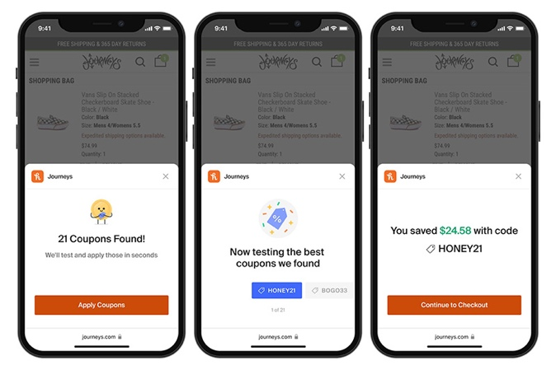

Honey pop up during the checkout of a product (Now integrated into Safari Browser on iPhone)

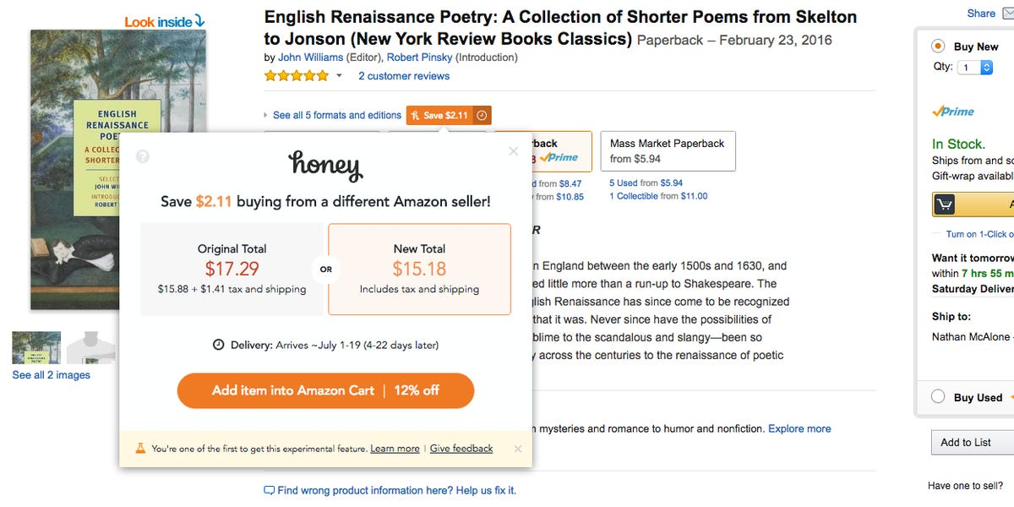

Amazon Dealer price comparison

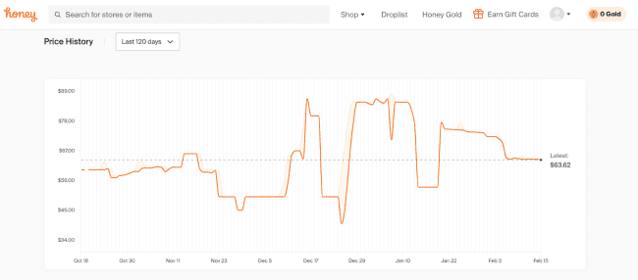

Honey’s price History of a product.

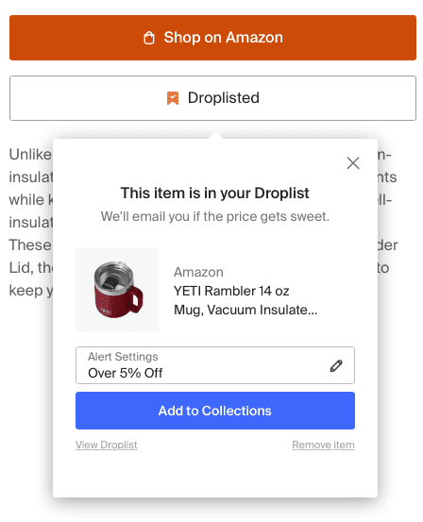

Product can be added into Wishlist and alert can be set for users.

## Data Collection

According to [Honey Privacy Policy](https://www.joinhoney.com/privacy), here are the data that Honey collected during usage.

* Name, email address, IP address, your device's unique ID (where available), member password and other registration information and other Pay Pal registration information.
* PayPal Honey Payment Information.
* Linked a social media profile (like Facebook) at sign-in.
* Payment information when you purchase gift cards or other products or services from PayPal Honey.
* Retail site information, item pricing, page views, …